“INTERNATIONAL TRAINING WORKSHOP ON
SAND AND DUST STORMS”
AND
“WEST ASIA COOPERATION MEETING ON SAND AND DUST STORMS”

12-15 November 2018, Istanbul, TURKEY

Background
Sand and Dust Storms (SDS) have a global, transboundary and multi-faceted impact on environment, health, industry, livelihood, urban infrastructure and agriculture. The intensity and frequency of dust events has increased in some areas including the West Asia. In the Middle East and North Africa, about USD 13 billion in Gross Domestic Product (GDP) are lost every year due to dust storms. Dust storms negatively affect air quality. The World Health Organization estimates that seven million people die due to poor air quality every year.
Immediate action is needed to prevent and mitigate impact of SDS at local to global scale.
The first ‘’Collaboration on Environment and Meteorology’’ was carried out by Republic of Turkey, Islamic Republic of Iran, Republic of Iraq, and Syrian Arab Republic at the level of Ministry of Environment and The Head of Environmental Protection Agency between 28 and 29 April, 2010 in Ankara, Turkey. In this meeting, “The Ankara Declaration’’ was signed to improve friendship and relationship on environment on 29 April, 2010 in Ankara. According to the Ankara Declaration, Ministers have decided to work together and share their experience and knowledge on environment, managing of air quality, meteorology, combating desertification, forestry, land reclamation, erosion control, and mitigation of sand and dust storms.
The second conference of the Ministries, ‘’Collaboration on Environment and Meteorology’’ was held between 26 and 29 September, 2010 in Tehran. As a result of this meeting, “The Action plan for Cooperation in the Field of Environment and Meteorology’’ was signed between Islamic Republic of Iran, Republic of Iraq, Syrian Arab Republic, Qatar, and Republic of Turkey. The Temporary Secretariat was established in Tehran.
The adoption of United Nations General Assembly (UNGA) resolution entitled ‘Combating sand and dust storms’ (A/RES/70/195) in 2015 has contributed to a greater global ambition to address SDS. At the request of UNGA, a Global Assessment of Sand and Dust Storms was published in partnership of UNEP, UNCCD and WMO. This report will be launched at the forthcoming UNGA session and is likely to advocate for further action on SDS at global level. The issue was discussed again at the Second Session of UN Environment Assembly (UNEA-2) held in Nairobi, Kenya in May 2016. The UNEA-2 adopted a resolution to establish a global research network on sand and dust storms.
The UNCCD is one of the key parts of global sand and dust storm actions. Nearly %77 of the UNCCD partnership countries are affected directly by SDS and 45 countries have main dust sources. Drought and sand and dust storms were discussed on the adoption of new policy documents at COP 13 (Ordos, CHINA) in 2017.
The Ankara Initiative is launched to strengthen implementation of the United Nations Convention to Combat Desertification (UNCCD) in the period 2016 to 2019. It will support the global sustainable development agenda and leverage the lessons learned from Turkey’s past experience and approaches to land management.

Our country has quite significant experiences in combating desertification/land degradation which is an important problem for the humankind and our planet. We are declared as one of the leading trainer countries by United Nations. Sharing our experiences with the countries under the threat of desertification in Central Asia, the Balkans and Africa complies with our country’s mission.
Republic of Turkey, Ministry of Forestry and Water Affairs organized a training on “Meteorological Services, Sand and Dust Storm (SDS) Forecast and Early Warning System” and “Erosion Preventing Techniques and Controlling Methods and Forestry” between 22 and 26 February 2011. “International Workshop on Meteorology, Sand and Dust Storms, Combating Desertification and Erosion” was held between 26 and 28 November 2012 in Ankara and Konya, Turkey. The third workshop on “International Meteorology, Sand and Dust Storms, Combating Desertification and Erosion” was held between 28 and 31 October 2013 in Istanbul, Turkey.
Following these workshops, “International Workshop on Sand and Dust Storms (SDS)” was held between 4 and 7 October 2016 in Istanbul and hosted by the Republic of Turkey, Ministry of Forestry and Water Affairs, General Directorate of Combating Desertification and Erosion (ÇEM) and Turkish State Meteorological Service (TSMS) with technical corporation of the United Nations Convention to Combat Desertification (UNCCD), the World Meteorological Organization (WMO) and the United Nations Environmental Programme (UNEP).
5th workshop which was titled as “Middle East (Regional) Dust Sources and Their Impacts” was held by Republic of Turkey, Ministry of Forestry and Water Affairs, General Directorate of Combating Desertification and Erosion (ÇEM) and Turkish State Meteorological Service (TSMS) between 23 and 25 October 2017 in Istanbul, Turkey. Minutes of this workshop were published online.

Republic of Turkey, Ministry of Agriculture and Forestry, Turkish State Meteorological Service (TSMS) and General Directorate of Combating Desertification and Erosion (ÇEM) will organize “International Training Workshop on Sand and Dust Storms” and “West Asia Cooperation Meeting on Sand and Dust Storms” between 12 and 15 November 2018 in Istanbul, Turkey.

Objective of the events:
To bring scientists studying particularly in the field of monitoring, forecast and evaluation of SDS, mitigation of dust sources and SDS impacts together to share their knowledge with the participants from related countries.

Subject of the workshop:
The workshop will focus on:
- Dust observation, forecast and evaluation,
- Monitoring sources causing sand and dust storms locally,
- Identify and scale up best-practice techniques for source mitigation,
- SDS impacts and adaptation

Subject of the meeting:
The meeting will focus on West Asia Dust Forecast Center and Regional Cooperation.

Format of the events:
The workshop will consist of presentations, working groups and case studies.
The meeting will be round table meeting.
The events will be in English.
Interpretation services will be provided only for the workshop.

Internet Facilities:
Internet will be available. Participants should bring their PCs.

Key Stakeholders and Expected Participants:
- WMO, UNEP, UNCCD, EUMETSAT, WHO, AEMET, BSC, AOAD
- UNCCD National Focal Points (UNCCD NFPs), Focal Points of National Meteorological Services, experts (SPI members), academicians from the Middle East, North Africa, and Central Asia
- Related scientists, decision makers and NGO’s involved in the sand and dust storms, dust sources, dust modeling and forecast, desertification, climate and meteorology.
Countries:
Afghanistan, Azerbaijan, Bahrain, Jordan, Iraq, Iran, Kazakhstan, Kyrgyzstan, Kuwait, Lebanon, Oman, Palestine, Pakistan, Qatar, Saudi Arabia, Tajikistan, Turkish Republic of Northern Cyprus (TRNC), Turkmenistan, United Arab Emirates, Uzbekistan, Yemen.

Application:
SDS National Focal Points of all West Asian countries who have good level of English are expected to attend these events. The candidates will apply via e-mail to the contact person, Afife Hande Türkyılmaz (ahturkyilmaz@mgm.gov.tr). Participants should be nominated by PR of their country with WMO (one nominated member and one alternate member from each country).

Required Documents for Application:
- Official Letter: A letter signed by the Permanent Representative of your country with WMO nominating you for the training course.
- Application Form: This form should be filled by the participant and signed it by Permanent Representative of your country with WMO and send with the official letter.
- Photocopy of passport: to be submitted with the application form, if you possess your passport which you will carry when entering Turkey for this training. If not, you are requested to submit its photocopy as soon as you obtain it. *Passport photocopy should include the following: Name. Date of Birth. Nationality. Sex. Passport number and Expire date.
Deadline for application:
Application forms with the necessary documents should be sent to Afife Hande Türkyılmaz (ahturkyilmaz@mgm.gov.tr) before 08 October 2018. Please “CC” Ayşe Gökçen Işık (agisik@mgm.gov.tr) to your email while sending your documents.

The Venue of the events:
The events will be held in General Directorate of State Hydraulic Works, 14th Regional Office of Training and R&D Facilities in Istanbul, Turkey.
Address: Cevizli, Mutlu Sok. Özveri Çıkmazı Orhantepe Ar-ge ve Eğitim Merkezi No:6, Maltepe/Istanbul
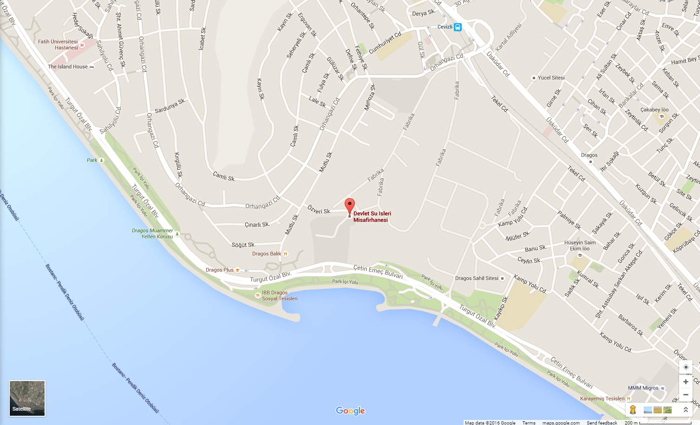

Logistics:
As the host of the events, Turkish Government will cover accommodation, meals and local transfers between the airport and the venue for all participants. We have limited budget for the flight tickets. For more information about logistics, please contact Afife Hande Türkyılmaz (ahturkyilmaz@mgm.gov.tr).

Insurance:
Participants are fully responsible for any expenses in the event of death, illness or injury attributable to the attendance at training and for arranging for such life, health and other form of insurance, as they consider appropriate. The participants are highly recommended to make a travel insurance that covers their travel and visit period. Organization accepts no responsibility for compensation in such events.

Currency:
The national currency is Turkish Lira (TL).
USD 1 = approximately 6,50 TL
EUR 1 = approximately 7,60 TL
Also you can check the following link: www.tcmb.gov.tr

Electricity:
220V plugs with two round pins are used in Turkey. A plug adapter is recommended.

Climate:
During winter months, the temperature is around 10 degrees (50 Fahrenheit) with much colder nights, lowest recorded temperature was -15 degrees (5 Fahrenheit).
For daily forecast, please check the below link:
https://www.mgm.gov.tr/?il=Istanbul
For maximum, minimum and average temperatures, please check the below link:
https://mgm.gov.tr/eng/forecast-cities.aspx?m=ISTANBUL

Business hours:
Banks: Governments offices and organizations: Post Offices:
Weekdays: 08:00 – 17:00 Weekdays: 9:00 -18:00 Weekdays: 8:00 -17:00
Weekends: Closed Weekends: Closed Weekends: Closed
All government organizations are closed on/during National Holidays.
Course coordinator:
Ms. Afife Hande TÜRKYILMAZ
Interpreter/Translator
Turkish State Meteorological Service
Phone: +90 312 302 2792
E-mail: ahturkyilmaz@mgm.gov.tr

